PROVINCE | INFORMATION LINKS | TODAYS IMPORTANT POINTS
Newfoundland | https://www.health.gov.nl.ca/health/publichealth/cdc/coronavirus/  Provincial Stats  https://covid-19-newfoundland-and-labrador-gnl.hub.arcgis.com/  April 28 Briefing  https://www.cpac.ca/en/programs/covid-19-canada-responds/episodes/66192853/  April 29 Briefing  https://www.cpac.ca/en/programs/covid-19-canada-responds/episodes/66193292/ | April 29  The Provincial Government is providing compensation for private sector employers for continuation of pay to employees who were required to self-isolate for 14-days due to the COVID-19 travel restrictions. This includes individuals who are self-employed.  https://www.gov.nl.ca/releases/2020/exec/0429n03/
PEI | https://www.princeedwardisland.ca/en/information/health-and-wellness/closures-due-covid-19  Provincial Stats  https://www.princeedwardisland.ca/en/topic/covid-19  April 28 Briefing  https://www.cpac.ca/en/programs/covid-19-canada-responds/episodes/66192827/  April 29 Briefing  https://www.cpac.ca/en/programs/covid-19-canada-responds/episodes/66193296/ | April 28  Renew PEI, Together outlines the guiding principles and phased approach to the reopening of businesses, services and public spaces. The first phase will begin Friday, May 1.  https://www.princeedwardisland.ca/en/news/province-outlines-plans-to-renew-pei-together  April 29  Government is confirming that recreational angling season will open on Friday, May 1, 2020. Normal angling regulations, as well as guidelines related to COVID-19, will be in effect.  https://www.princeedwardisland.ca/en/news/recreational-angling-season-open-may-1
Nova Scotia | https://novascotia.ca/coronavirus/  Provincial Stats  https://novascotia.ca/coronavirus/data/  April 28 Briefing  https://www.cpac.ca/en/programs/covid-19-canada-responds/episodes/66192894/  April 29 Briefing  https://www.cpac.ca/en/programs/covid-19-canada-responds/episodes/66193310/ | April 28  Today, April 28, Nova Scotia is reporting three additional deaths related to COVID-19, bringing the total to 27. The deaths occurred at the Northwood long-term care home in Halifax Regional Municipality.  https://novascotia.ca/news/release/?id=20200428003  April 29  Today, April 29, Nova Scotia is reporting one additional death related to COVID-19, bringing the total to 28. The death occurred at the Northwood long-term care home in Halifax Regional Municipality.  https://novascotia.ca/news/release/?id=20200429002
New Brunswick | https://www2.gnb.ca/content/gnb/en/departments/ocmoh/cdc/content/respiratory_diseases/coronavirus.html  Provincial Stats  https://www2.gnb.ca/content/gnb/en/departments/ocmoh/cdc/content/respiratory_diseases/coronavirus/case-map.html  April 28 Briefing  https://www.cpac.ca/en/programs/covid-19-canada-responds/episodes/66192886/  April 29 Briefing  https://www.cpac.ca/en/programs/covid-19-canada-responds/episodes/66193300/ | April 28  Testing protocols in New Brunswick for COVID-19 are being expanded to capture a wider range of symptoms for the disease.  https://www2.gnb.ca/content/gnb/en/news/news_release.2020.04.0235.html  April 29  Public Health reports no new cases of COVID-19 today. The number of confirmed cases in New Brunswick remains at 118; the number of active cases is four and 114 people have recovered. One person remains hospitalized and there are no patients in an intensive care unit.  https://www2.gnb.ca/content/gnb/en/news/news_release.2020.04.0237.html
Quebec | https://www.quebec.ca/en/health/health-issues/a-z/2019-coronavirus/  Provincial Stats  https://www.quebec.ca/en/health/health-issues/a-z/2019-coronavirus/situation-coronavirus-in-quebec/#c47900  April 27 Briefing  https://www.cpac.ca/en/programs/covid-19-canada-responds/episodes/66192334/ Easing restrictions  April 28 Briefing  https://www.cpac.ca/en/programs/covid-19-canada-responds/episodes/66192813/  April 29  https://www.cpac.ca/en/programs/covid-19-canada-responds/episodes/66193283/ | April 28  Safety measures for workers and children in elementary schools and daycare services during COVID-19  https://www.quebec.ca/en/education/preschool-elementary-and-secondary-schools/etablissements-scolaires-prescolaires-primaires-et-secondaires-dans-le-contexte-de-la-covid-19/safety-measures-for-workers-and-children-in-elementary-schools-and-daycare-services-during-covid-19/  On April 28, 2020, the government announced the gradual reopening of various sectors and businesses. The reopenings, approved by public health authorities, will occur in phases according to the areas of activity and geographic zones. Consequently, in the coming weeks the resumption of activities will be authorized. However, measures must be implemented to ensure the health and safety of workers and customers.  https://www.quebec.ca/en/health/health-issues/a-z/2019-coronavirus/gradual-resumption-activities-covid19-related-pause/#c57361  April 29  Deputy premier Geneviève Guilbault, who replaced Premier François Legault at Wednesday's news conference, said authorities will gradually remove restrictions on travel within the province, beginning May 4.
Ontario | https://www.ontario.ca/page/2019-novel-coronavirus  Provincial Stats  https://www.ontario.ca/page/2019-novel-coronavirus#section-0  April 28 Briefing  https://www.cpac.ca/en/programs/covid-19-canada-responds/episodes/66192817/  https://www.cpac.ca/en/programs/covid-19-canada-responds/episodes/66192898/  April 29 Briefing  https://www.cpac.ca/en/programs/covid-19-canada-responds/episodes/66193288/  https://www.cpac.ca/en/programs/covid-19-canada-responds/episodes/66193316/ | April 28  The Ontario government is launching the COVID-19: Tackling the Barriers website to help businesses overcome the unique challenges created by the global pandemic.  https://news.ontario.ca/opo/en/2020/04/ontario-helping-businesses-overcome-the-unique-challenges-created-by-covid-19.html  April 29  The Ontario government is further expanding the list of essential workers eligible to receive free emergency child care during the COVID-19 outbreak.  https://news.ontario.ca/opo/en/2020/04/more-frontline-workers-eligible-for-emergency-child-care.html
Manitoba | https://www.gov.mb.ca/covid19/index.html  Provincial Stats  https://www.gov.mb.ca/covid19/updates/index.html#cases  April 28 Briefing  https://www.cpac.ca/en/programs/covid-19-canada-responds/  April 29 Briefing  https://www.cpac.ca/en/programs/covid-19-canada-responds/episodes/66191353/ | April 28  Public health officials advise no new cases of COVID-19 have been identified as of 9:30 a.m. today. The total number of lab-confirmed positive and probable positive cases in Manitoba remains at 272.  https://news.gov.mb.ca/news/index.html?item=47662  April 29  Public health officials advise one new case of COVID-19 has been identified as of 9:30 a.m. today, bringing the total number of lab-confirmed positive and probable positive cases in Manitoba to 273.  https://news.gov.mb.ca/news/index.html?item=47665
Saskatchewan | https://www.saskatchewan.ca/government/health-care-administration-and-provider-resources/treatment-procedures-and-guidelines/emerging-public-health-issues/2019-novel-coronavirus  Provincial Stats  https://www.saskatchewan.ca/government/health-care-administration-and-provider-resources/treatment-procedures-and-guidelines/emerging-public-health-issues/2019-novel-coronavirus/cases-and-risk-of-covid-19-in-saskatchewan  April 28 Briefing  https://www.cpac.ca/en/programs/covid-19-canada-responds/episodes/66193001/  April 29 Briefing  https://www.cpac.ca/en/programs/covid-19-canada-responds/episodes/66193320/ | April 28  As of April 28, 2020, Saskatchewan has one new confirmed case of COVID-19 in the Regina region, bringing the provincial total to 366.  https://www.saskatchewan.ca/government/news-and-media/2020/april/28/covid-19-update-april-28  Today, the Saskatchewan Health Authority (SHA) released new data showing that Saskatchewan is in a significantly better position to manage COVID-19 as a result of the interventions taken to date to slow the spread of the virus.  https://www.saskatchewan.ca/government/news-and-media/2020/april/28/updated-pandemic-modelling  April 29  A Saskatchewan resident in their 80s from the far north region has died from complications related to COVID-19. There are now six deaths in the province as a result of being infected with the virus.  https://www.saskatchewan.ca/government/news-and-media/2020/april/29/covid-19-update-april-29
BC | http://www.bccdc.ca/health-info/diseases-conditions/covid-19  Provincial Stats  http://www.bccdc.ca/health-info/diseases-conditions/covid-19/case-counts-press-statements  April 28 Briefing  https://www.cpac.ca/en/programs/covid-19-canada-responds/episodes/66193031/  https://www.cpac.ca/en/programs/covid-19-canada-responds/episodes/66191341/  April 29 Briefing  https://www.cpac.ca/en/programs/covid-19-canada-responds/episodes/66193514/ | April 28  Adrian Dix, Minister of Health, and Dr. Bonnie Henry, B.C.’s provincial health officer, have issued the following joint statement regarding updates on the novel coronavirus (COVID-19) response in British Columbia  https://news.gov.bc.ca/releases/2020HLTH0021-000778  April 29  Adrian Dix, Minister of Health, and Dr. Bonnie Henry, B.C.'s provincial health officer, have issued the following joint statement regarding updates on the novel coronavirus (COVID-19) response in British Columbia  https://news.gov.bc.ca/releases/2020HLTH0022-000785  The provincial state of emergency is being extended for the third time, to support the extraordinary measures taken by the Province under the Emergency Program Act to keep people safe during the COVID-19 pandemic. https://news.gov.bc.ca/releases/2020EMBC0022-000783
Alberta | https://www.alberta.ca/coronavirus-info-for-albertans.aspx  Provincial Stats  https://www.alberta.ca/covid-19-alberta-data.aspx  April 28 Briefing  https://www.cpac.ca/en/programs/covid-19-canada-responds/episodes/66193027/  April 29 Briefing  https://www.cpac.ca/en/programs/covid-19-canada-responds/episodes/66193324/ | April 28  The Government of Alberta has introduced a new “low” modelling scenario estimating 298 Albertans will require hospitalization and 95 will require critical care when the virus reaches its peak. If current trends continue, this scenario will become the most likely scenario for Alberta.  https://www.alberta.ca/release.cfm?xID=701959A892092-D9E7-E7AA-585AF9B3CA8BCEAA  April 29  A strategy is in place to identify and respond to COVID-19 outbreaks. It involves three elements: prevention and preparedness, rapid response and timely notification, and outbreak management.  https://www.alberta.ca/release.cfm?xID=70208D37E2686-C59F-499C-F0513A6DF7C41244
NWT | https://www.hss.gov.nt.ca/en/services/coronavirus-disease-covid-19  Territorial Stats  https://www.hss.gov.nt.ca/en/services/coronavirus-disease-covid-19  April 28 Briefing  https://www.cpac.ca/en/programs/covid-19-canada-responds/episodes/66192974/ | April 28  The territory-wide Public Health Emergency and State of Emergency have been extended in the Northwest Territories. Both extensions will take effect as of April 29, 2020 and expire on May 12, 2020.  https://www.gov.nt.ca/en/newsroom/gnwt-extends-territorial-public-health-emergency-and-state-emergency  April 29  This week, we’ve been focused on planning for emerging gradually, and safely, from our current levels of public health restrictions.  https://www.gov.nt.ca/en/newsroom/dr-kami-kandola-opening-remarks-weekly-media-briefing
Nunavut | https://www.gov.nu.ca/health/information/covid-19-novel-coronavirus  Territorial Stats  https://www.gov.nu.ca/health/information/covid-19-novel-coronavirus  April 29 Briefing  https://www.cpac.ca/en/programs/covid-19-canada-responds/episodes/66193503/ | April 29  There are three conditions that need to be met before we can consider relaxing existing restrictions in the territory.  https://www.gov.nu.ca/health/news/covid-19-department-health-services-update
Yukon | https://yukon.ca/covid-19  Territorial Stats  https://yukon.ca/covid-19  April 28 Update  https://www.cpac.ca/en/programs/covid-19-canada-responds/episodes/66193023/ | April 28  Yukon’s Chief Medical Officer of Health Dr. Brendan Hanley has the following updates for the Yukon public on measures being taken in response to the COVID-19 pandemic.  https://yukon.ca/en/news/april-28-2020-yukons-chief-medical-officer-health-provides-update-covid-19  Yukon seniors will remain mobile and commercial drivers can continue deliveries during the COVID-19 pandemic following passage of a new Driver Medical Order.  https://yukon.ca/en/health-and-wellness/covid-19/updates-covid-19-pandemic-week
Canada Soccer | Canada Soccer values the safety of its players, coaches, officials, staff and fans as its highest priority. As the national governing body for the sport of soccer in the country, we have been and will continue to closely monitor all COVID-19 developments in consultation with the Public Health Agency of Canada and relevant governing bodies through the Canada Soccer Sport Medicine Committee. | https://www.canadasoccer.com/canada-soccer-covid-19-update-p162611
Baseball Canada | Baseball Canada also recommends that its member provinces consider appropriate action for their respective provincial situations. We invite players, coaches, umpires and scorekeepers to reach out to their respective provincial baseball associations for more information on the provincial activities. Baseball Canada is currently working on a plan for coach and umpire training using technology that will allow for remote accessibility. | https://www.baseball.ca/update-march-20-2020---baseball-canada-announces-event-cancellations-due-to-covid-19
Golf Canada | Golf Canada continues to evaluate all aspects of our business and take precautions for the well being of our athletes, staff, coaches, partners and volunteers. Cost controls and risk mitigation protocols have been enacted and we are working with our provincial, national and international partners along with our member clubs to gather the information we need to make informed and responsible decisions. | https://golfcanada.ca/covid-19/
Softball Canada | 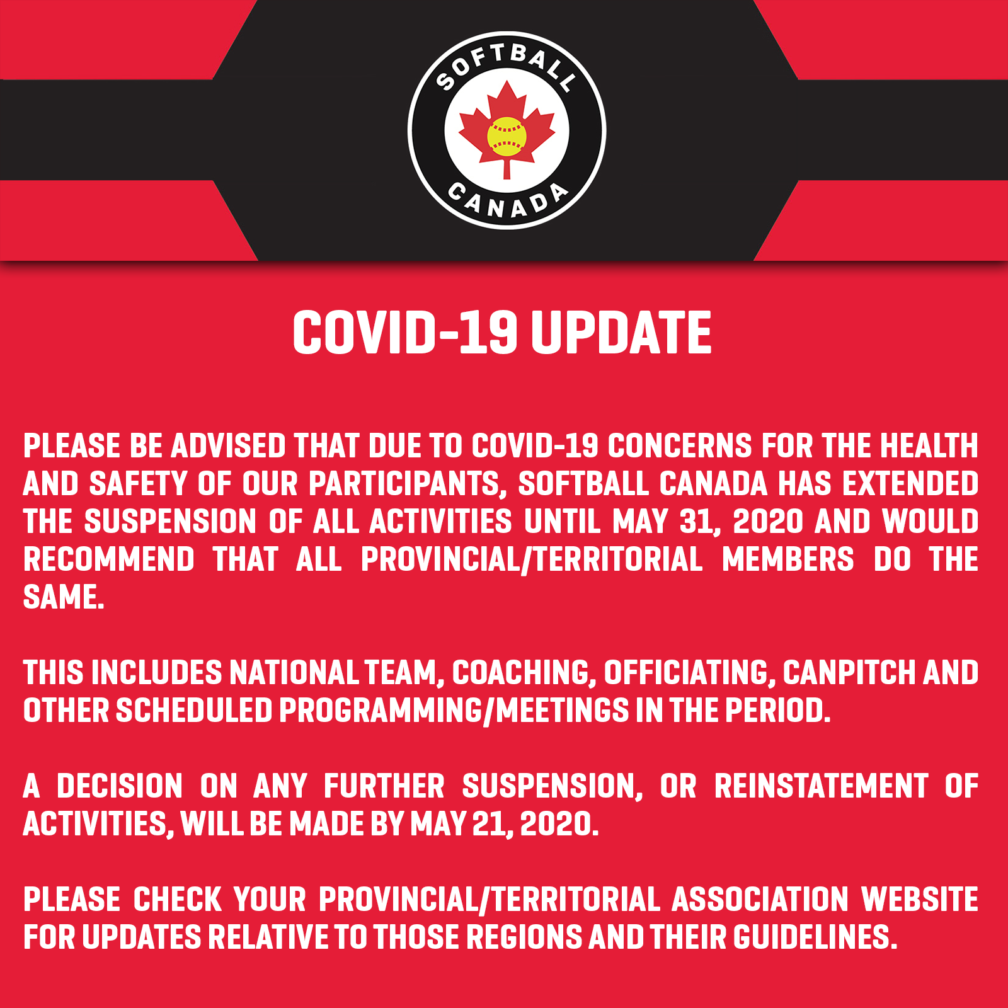 | https://softball.ca/news/covid-19-notice.htm
Swimming Canada | Following the lead of the International Olympic Committee, International Paralympic Committee, Canadian Olympic Committee and Canadian Paralympic Committee, Swimming Canada has announced the cancellation of all summer 2020 national events due to the global COVID-19 pandemic. | https://www.swimming.ca/en/news/2020/03/27/remaining-2020-national-events-cancelled/
Football Canada | The Football Canada Board of Directors have voted unanimously to recommend suspension of face-to-face meetings or gatherings, training, practice and play for all members indefinitely due to the issues surrounding the Coronavirus pandemic. This reiterates the bulletin and policy position distributed on March 12 to all members and the public. Football Canada continues to monitor the public health situation regarding the novel Coronavirus, also known as COVID-19. | http://footballcanada.com/football-canada-policy-update-on-covid-19/  March 2http://footballcanada.com/football-canada-policy-update-on-covid-19-2/0 Update  April – AGM Rescheduled  http://footballcanada.com/football-canada-agm-to-be-rescheduled/
Diving Canada | During this time of isolation and facility closures, the national office, the DPC board of directors and the  provincial sections have been keeping connected through weekly teleconferences. During the most recent call,  Diving Plongeon Canada and the provincial sections made the decision to cancel the remainder of the 2020  competition season, including all national qualifying events and the junior national championships.  We have not yet ruled out the possibility of holding a summer senior national championship. This decision  depends primarily on when conventional training can resume, the assessed needs of our senior athletes and the  importance of competing in a national level competition prior to the start of the 2020-21 season. | https://diving.ca/wp-content/uploads/2020/04/EN-Technical-Bulletin-April-1st-2020.pdf
Basketball Canada | CEBL STATEMENT REGARDING START OF 2020 REGULAR SEASON  TORONTO, Ont. (April 15, 2020) -- The Canadian Elite Basketball League (CEBL) announced Wednesday that the start of the 2020 season has been delayed until June as a result of the COVID-19 outbreak. | https://www.basketball.ca/en/news-article/cebl-statement-regarding-start-of-2020-regular-season
Vollyball Canada | "As the pandemic evolved it became clear that measures such as bans on large gatherings, social distancing and travel restrictions would continue through May and potentially beyond," said Mark Eckert, president and CEO of Volleyball Canada. "This was a joint decision with our partner Edmonton Events, and although we are disappointed to have to cancel this year’s events, the welfare of participants and fans is our greatest concern at all times." | https://volleyball.ca/en/news/volleyball-canada-update-covid-19
Wrestling Canada | OTTAWA – Due to safety concerns surrounding the spread of the COVID-19 virus, Wrestling Canada Lutte has cancelled the Junior / Senior and U17 / U 19 Canadian Championships, as well as the 2020 Canada Cup. | https://wrestling.ca/wcl-announces-cancellation-of-2020-events-same-host-cities-for-2021/
Gymnastics Canada | CANCELLED EVENTS  TG World Cup - Arosa (SUI)  MAG/WAG World Cup - Tokyo (JPN)  MAG/WAG World Cup - Birmingham (GBR)  MAG Junior Team Cup - Berlin (GER)  MAG/WAG World Cup - Baku (AZE) - the finals of this event have now been cancelled.  WAG Jesolo Cup (ITA)  MAG/WAG World Cup - Stuttgart (GER)  POSTPONED EVENTS  2020 Olympic Games - Tokyo (JPN)  AG World Challenge Cup - Varna (BUL)  RG World Challenge Cup - Portimao (POR)  RG World Challenge Cup - Minsk (BLR)  RG World Challenge Cup - Moscow (RUS)  2020 Senior Pan American Championships - Utah (USA)  2020 Pacific Rim Championships - Tauranga (NZL)  RG World Cups - Sofia (BUL), Tashkent (UZE), Baku (AZE) -- all of these events have now been postponed.  RG World Cup - Pesaro (ITA)  TG World Cup - Brescia (ITA) – event postponed to June 19-20, 2020  AG World Cup - Doha (QAT) – event postponed to June 3-6, 2020 | http://www.gymcan.org/news/details/2020_Gymcan_Covid_EN
Field Hockey | UPDATE MARCH 14, 2020  Field Hockey Canada continues to monitor the situation with COVID-19. Yesterday a steering committee was put in place to oversee FHC’s response and to ensure the best course of action is taken for our athletes and our community, both for the immediate and longer-term future. As of today, March 14, 2020, all Field Hockey Canada national teams will cease group training activities. This applies to all activity, including gym, on-field and other group sessions, inclusive of senior, junior, masters and both the indoor and outdoor programs. This cessation will be in effect until March 31 2020 at the earliest. | http://www.fieldhockey.ca/2020/03/12/field-hockey-canada-statement-covid-19/

PROVINCE | CURRENT EMERGENCY STATUS | IN PLACE UNTIL
BC  Vancouver | http://www.bccdc.ca/health-info/diseases-conditions/covid-19?utm_campaign=20200318_GCPE_AM_COVID_3_NOTIFICATION_BCGOVNEWS_BCGOV_EN_BC__NOTIFICATION  https://vancouver.ca/news-calendar/vancouver-city-council-declares-local-state-of-emergency.aspx | May 12  https://news.gov.bc.ca/releases/2020EMBC0022-000783
ALBERTA  Calgary | https://www.alberta.ca/coronavirus-info-for-albertans.aspx  https://newsroom.calgary.ca/city-of-calgary-declares-state-of-local-emergency/ | In place until rescinded by CMO
SASKATCHEWAN | https://www.saskatchewan.ca/government/news-and-media/2020/march/18/covid-19-state-of-emergency | April 29th  https://regina.ctvnews.ca/sask-state-of-emergency-to-remain-in-place-for-another-two-weeks-1.4897651
MANITOBA | https://news.gov.mb.ca/news/?archive=&item=47137 | May 1st
NWT | https://www.gov.nt.ca/en/newsroom/gnwt-extends-territorial-public-health-emergency-and-state-emergency | May 12th
NUNAVUT | https://gov.nu.ca/health/news/covid-19-department-health-services-update | April 16th
YUKON | https://yukon.ca/en/news/yukon-declares-state-emergency-response-covid-19 | In place for 90 days (In place March 27th)
ONTARIO  Toronto | https://news.ontario.ca/opo/en/2020/04/ontario-extends-emergency-orders-to-help-stop-the-spread-of-covid-19.html  https://www.toronto.ca/home/covid-19/ | May 6  https://news.ontario.ca/opo/en/2020/04/ontario-extends-declaration-of-emergency-to-continue-the-fight-against-covid-19
NOVA SCOTIA | https://novascotia.ca/coronavirus/alerts-notices/#provincial-state-emergency | May 3, 2020
NEW BRUNSWICK | https://www2.gnb.ca/content/dam/gnb/Corporate/pdf/EmergencyUrgence19.pdf | April 30th, 2020
NEWFOUNDLAND | https://www.gov.nl.ca/covid-19/files/Public-Health-Emergency-Extension-Declaration-April-16-2020.pdf | May 1, 2020
PEI | https://www.princeedwardisland.ca/en/news/prince-edward-island-declares-a-state-of-emergency  https://www.princeedwardisland.ca/en/news/prince-edward-island-releases-covid-19-modeling | May 31st

